**MicroROS Zephyr ADXL372 Sensor Test**

Firmware/zephyr_apps/apps/

Copy altitude_estimator example and Rename adxl372_test

1. **MicroROS Setup**

# Source the ROS 2 installation

$source /opt/ros/foxy/setup.bash

#Create a workspace and download the micro-ROS build

$mkdir microros_ws

$cd microros_ws

$git clone -b $ROS_DISTRO https://github.com/micro-ROS/micro_ros_setup.git src/micro_ros_setup

#Update dependencies using rosdep

$sudo apt update && rosdep update

$rosdep install --from-path src --ignore-src -y

#Install Pipe

sudo apt-get install python3-pip

/* Need to install once */

#Colcon Installation

$sudo apt install python3-colcon-common-extensions

#Build micro-ROS tools and source them

colcon build

source install/local_setup.bash

1. **Create a micro-ROS Agent**

ros2 run micro_ros_setup create_agent_ws.sh

ros2 run micro_ros_setup build_agent.sh

1. **Create firmware for build-in Board**

ros2 run micro_ros_setup create_firmware_ws.sh zephyr stm32f429i_disc1

1. **Add Custom Message**

For instructions for tf2_msgs, Check the link:

<https://github.com/micro-ROS/zephyr_apps/tree/foxy/apps/attitude_estimator>

Add tf2_msgs package, before building the app download and add this package to mcu_ws folder

cd firmware/mcu_ws

git clone -b foxy https://github.com/ros2/geometry2

cp -R geometry2/tf2_msgs .

rm -rf geometry2

1. **Modify CMakeList.txt Line 5 to below**

*firmware/zephyr_apps/app/ping_pong1/CMakeLists.txt*

set(COMPATIBLE_BOARDS stm32f429i_disc1 disco_l475_iot1 olimex_stm32_e407 native_posix nucleo_h743zi nucleo_f746zg)

/**** SPI5, PE4 is CS, PE6 is INT1 ******************/

1. **Add .overlay file into MicroROS App**

1.Create Board folder into firmware/zephyr_apps/app/ping_pong1/

2.Create file as : stm32f429i_disc1.overlay.

3.Edit as the following [*Use SPI5, PE4 is CS, PE6 is INT1* ]

&spi5 {

cs-gpios = <&gpioe 4 GPIO_ACTIVE_LOW>;

adxl372@0 {

compatible = "adi,adxl372";

reg = <0>;

spi-max-frequency = <8000000>;

label = "ADXL372";

int1-gpios = <&gpioe 6 GPIO_ACTIVE_HIGH>;

};

};

1. **Check LED and Switch**

const struct device *led = device_get_binding(DT_GPIO_LABEL(DT_ALIAS(led0), gpios));

Firmware/zephyrproject/zephyr/boards/arm/disco_l475_iot1/disco_l475_iot1.dts

aliases {

led0 = &green_led_2;

led1 = &green_led_1;

sw0 = &user_button;

eswifi0 = &wifi0;

};

Firmware/zephyrproject/zephyr/boards/arm/stm32f429i_disc1/stm32f429i_disc1.dts

aliases {

led0 = &green_led_4;

sw0 = &user_button;

};

1. **Check Sensor**

const struct device *imu_sensor = device_get_binding(DT_LABEL(DT_INST(0, adi_adxl372)));

Check into the following directory:

*Zephyrproject/zephyr/drivers/sensor/adxl372/ adxl372.c file*

#define DT_DRV_COMPAT adi_adxl372

*Zephyrproject/zephyr/drivers/sensor/lis3mdl/lis3mdl.c*

#define DT_DRV_COMPAT st_lis3mdl_magn

*Zephyrproject/zephyr/drivers/sensor/lis3mdl/lis3mdl_trigger.c*

#define DT_DRV_COMPAT st_lis3mdl_magn

*Zephyrproject/zephyr/drivers/sensor/adxl372/adxl372_trigger.c*

#define DT_DRV_COMPAT adi_adxl372

*Zephyrproject/zephyr/drivers/sensor/lsm6dsl_spi.c*

1. **Device Tree**

Zephyrproject/Zephyr/include/devicetree.h

1. **Change Peak Detect Mode and Measurement Mode**

Default Settings is ADXL372_PEAK_DETECT_MODE.

If you want to change to ADXL372_MEASUREMENT_MODE,

Go to /zephyrproject/zephyr/drivers/sensor/adxl372/

Edit Kconfig: Line 30 to

choice

prompt "Operating mode"

default ADXL372_MEASUREMENT_MODE

1. **Firmware Configuration**

source /opt/ros/foxy/setup.bash

source install/local_setup.bash

ros2 run micro_ros_setup configure_firmware.sh ping_pong1 --transport serial --dev 1

1. **Build firmware**

ros2 run micro_ros_setup build_firmware.sh

MicroROS sensor

Sensor.h

zephyrproject/zephyr/include/drivers/sensor.h

//

Compare with Pure sensor

zephyr/include/sensor.h

zephyrproject/zephyr/include/devicetree.h

**Create and Build Agent**

New Terminal

$cd microros_waveshare/

$source /opt/ros/foxy/setup.bash

$source install/local_setup.bash

$ros2 run micro_ros_setup create_agent_ws.sh

$ros2 run micro_ros_setup build_agent.sh

**Running Agent**

source /opt/ros/foxy/setup.bash

source install/local_setup.bash

ros2 run micro_ros_agent micro_ros_agent serial --dev /dev/ttyUSB0 -v 6

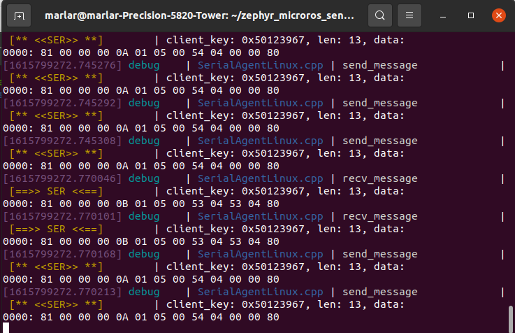

Client Start sending data to an enabled agent

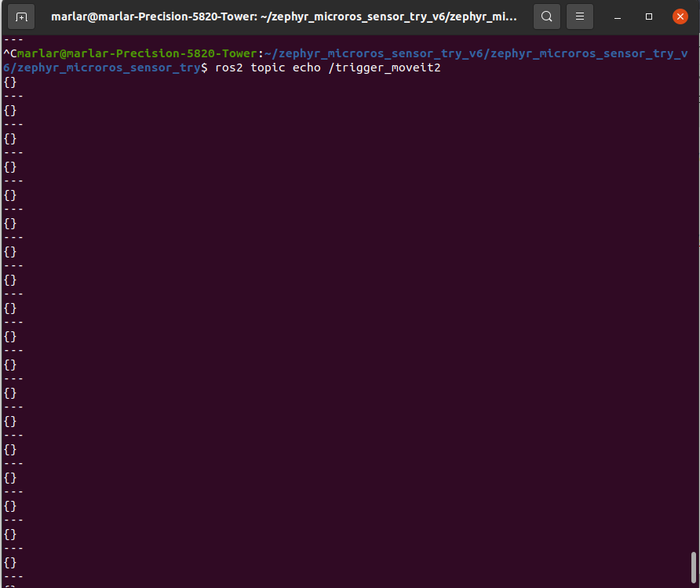

Client send the data and correctly received by the agent

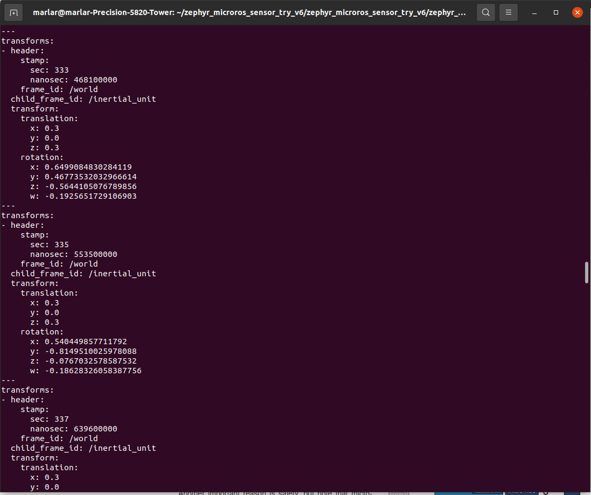

Value change

Zephyr-apps/apps/example project

1. App-colcon.meta

{

"names": {

"rmw_microxrcedds": {

"cmake-args": [

"-DRMW_UXRCE_MAX_NODES=1",

"-DRMW_UXRCE_MAX_PUBLISHERS=3",

"-DRMW_UXRCE_MAX_SUBSCRIPTIONS=0",

"-DRMW_UXRCE_MAX_SERVICES=0",

"-DRMW_UXRCE_MAX_CLIENTS=0",

"-DRMW_UXRCE_MAX_HISTORY=1"

]

}

}

}

1. Serial.conf

CONFIG_MAIN_STACK_SIZE=25000

CONFIG_MAIN_THREAD_PRIORITY=3

CONFIG_NEWLIB_LIBC=y

CONFIG_NEWLIB_LIBC_NANO=n

CONFIG_CPLUSPLUS=y

CONFIG_LIB_CPLUSPLUS=y

CONFIG_PTHREAD_IPC=n

CONFIG_POSIX_API=y

CONFIG_NATIVE_POSIX_TIMER=y

CONFIG_APP_LINK_WITH_POSIX_SUBSYS=y

CONFIG_POSIX_CLOCK=y

CONFIG_I2C=y

CONFIG_GPIO=y

CONFIG_SENSOR=y

CONFIG_VL53L0X=y

CONFIG_VL53L0X_PROXIMITY_THRESHOLD=100

CONFIG_SPI=y

CONFIG_LSM6DSL=y

CONFIG_LSM6DSL_TRIGGER_GLOBAL_THREAD=y

CONFIG_LIS3MDL=y

CONFIG_LIS3MDL_ODR="80"

CONFIG_PRINTK=y

CONFIG_RING_BUFFER=y

CONFIG_STDOUT_CONSOLE=y

CONFIG_SERIAL=y

CONFIG_UART_INTERRUPT_DRIVEN=y

CONFIG_BOOT_BANNER=n

Sensorfusion9.c/.h

Main.c

Boards/ .overlay

/*

* Copyright (c) 2019 Linaro Limited

*

* SPDX-License-Identifier: Apache-2.0

*/

&spi5 {

cs-gpios = <&gpiof 6 GPIO_ACTIVE_LOW>;

adxl372@0 {

compatible = "adi,adxl372";

reg = <0>;

spi-max-frequency = <8000000>;

label = "ADXL372";

int1-gpios = <&gpioe 6 GPIO_ACTIVE_HIGH>;

};

};

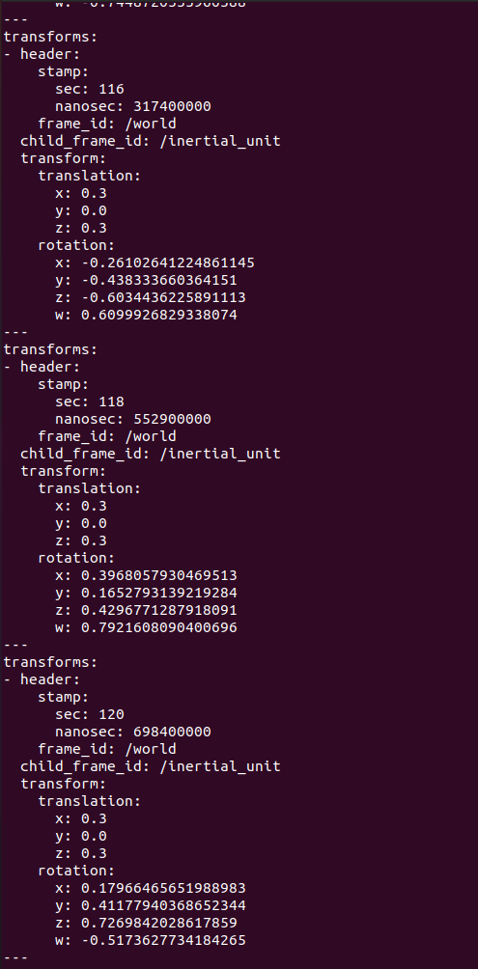

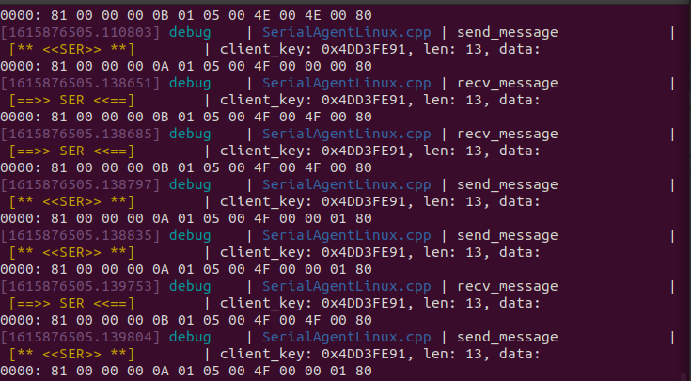

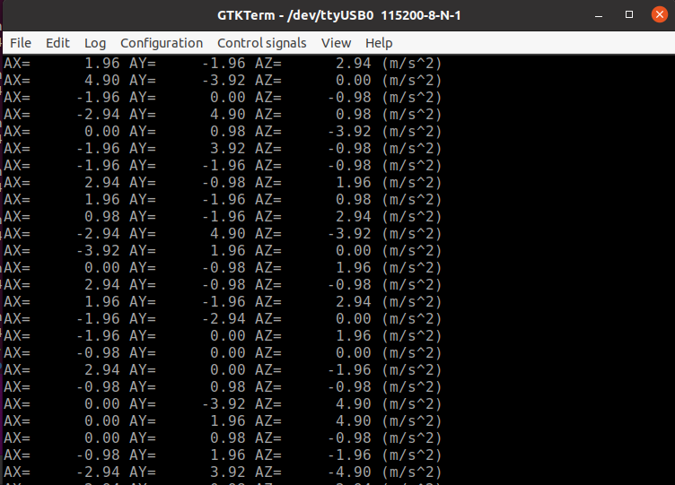

Add Subscriber

Test with Generic Data

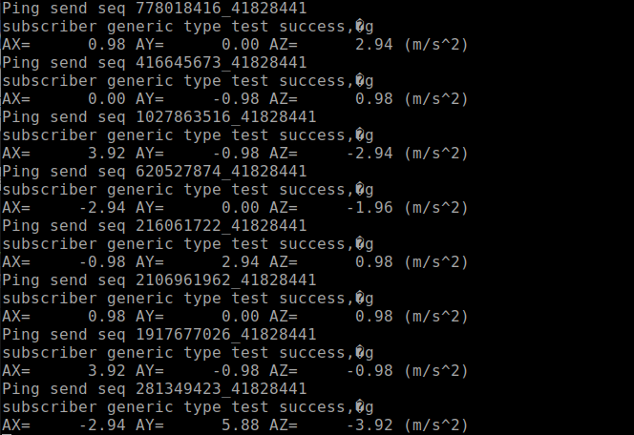

Test with Geometric data

ros2 topic pub --once /microROS/trigger_moveit2

Sample

ros2 topic pub --once /turtle1/cmd_vel geometry_msgs/msg/Twist "{linear: {x: 2.0, y: 0.0, z: 0.0}, angular: {x: 0.0, y: 0.0, z: 1.8}}"

ros2 topic list

/microROS/euler

/microROS/ping

/microROS/pong

/microROS/tf

/microROS/trigger_moveit2

/parameter_events

/rosout

$ ros2 topic list -t

/microROS/euler [geometry_msgs/msg/Vector3]

/microROS/ping [std_msgs/msg/Header]

/microROS/pong [std_msgs/msg/Header]

/microROS/tf [tf2_msgs/msg/TFMessage]

/microROS/trigger_moveit2 [std_msgs/msg/Empty]

/parameter_events [rcl_interfaces/msg/ParameterEvent]

/rosout [rcl_interfaces/msg/Log]